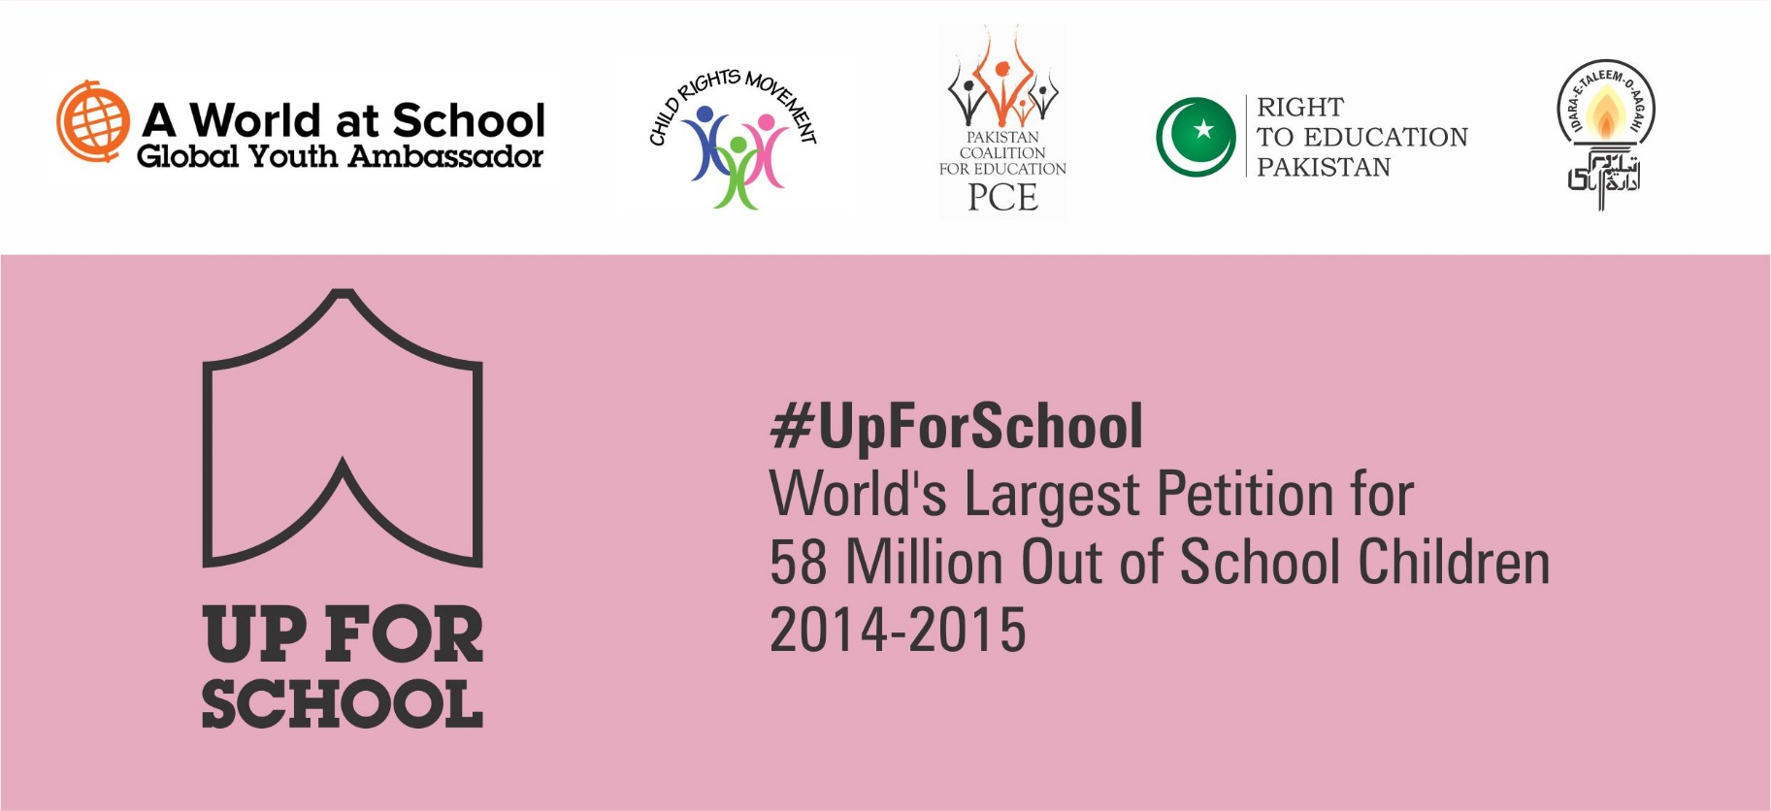
#UpForSchool Petition

#UpForSchool – World’s Largest Petition for 58 Million Out of School Children 2014-2015
Dear Friends and education supporters,
The Right to Education (RTE) team at Idara-e-Taleem-o-Aagahi (ITA), in collaboration with A World at School, would like to invite you to become a part of a global movement to help get every child into school and learning.
The #UpForSchool campaign is a universal petition to bring together everyone who shares the common belief that every child has the right to go to school, without danger and without discrimination. Young people from around the world are already making their voices heard and are putting pressure on world leaders to keep their promise to achieve universal education by 2015.
The #UpForSchool petition has already been backed by a unique group of key allies, to include businesses, influential individuals, world leaders, youth, faith groups, NGOs and civil society. UN Secretary- General Ban Ki-moon, Former UK Prime minister Gordon Brown, and Nobel prize-winner Malala Yousafzai are amongst those that have shown their support.
The campaign seeks to build the world’s largest petition and we ask for your help to make this historic achievement happen. By calling upon your network to sign on to the petition we can achieve our target to collect 3 million signatures in Pakistan by 31st January 2015.
How to mobilize your campaign
- Visit http://rtepakistan.org/upforschool-petitions/ to print off the signature forms
- Collect signatures from all your students/faculty/associates/ workers
- Send the completed signature forms, either electronically or via post to:
Zaynah Gilani and/or Waseem Khan
RTE Campaign Manager RTE Campaign
House No. 11, Street 38 House No. 11, Street 38
F-6/1, Islamabad, Pakistan F-6/1, Islamabad, Pakistan
zaynah.gilani@itacec.org waseem.ita@gmail.com
Landline: 051-2824838 & Cell: +92(0)3005166487

Please note:
- The head of the institution/department has to sign authorizing the authenticity of the signatures and agreement to be a part of this campaign –this is on the first page of the signature forms
- In order for the signature to be counted, we need ALL the following details: first name, last name, village, as well as the signature. If someone is unable to sign then a thumb impression would be valid.
- If you have more than one branch/department, then please attach a summary sheet of all branches/departments on the top so that we can easily count the number of signatures from each sheet.

Every signature counts and your support can go a long way to help get children into school and learning. As an appreciation of your time and efforts, there will be a number of incentives offered. Please visit http://rtepakistan.org/upforschool-petitions/ for more information.

Thanking you in anticipation.

With Best Wishes,

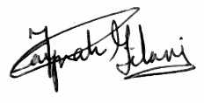
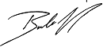
Baela Raza Jamil  Director Programs  Idara-e-Taleem-o-Aagahi (ITA) |  | Zaynah Gilani  RTE Campaign Manager  Idara-e-Taleem-o-Aagahi (ITA)

Commitment Note to be part of the #UpForSchool - World’s Largest Petition for
58 million Out of School Children

Our Institution (Name of the school/ college/ university and/or depts/ company/ NGO/ I-NGO ) ______________________________________________________________________ agree to be part of this campaign.

We hope to send _________ signatures for this petition by ____________________ (dd-mm-year)

We will abide by all steps shared in the letter of invite

Name: __________________________________________________________________________
Title/Designation: _______________________________________________________________
Address: _______________________________________________________________________
________________________________________________________________________________
Contact #: ______________________________________________________________________

Email: _________________________________________________________________________

Signature: ___________________________ Date: ________________________

Summary Sheet
SR # | Names of School/ Institute /Department/ Colleges | No of signatures collected | Name head of School/ Institute /Department/ Colleges
 | Total No of Signatures collected

Signed by Head of the Institution / Schools or focal person _________________________________

Name ____________________________________________________________________________

Title ____________________________________________________________________________

Date ___________________________________

Article 25 A:
“The state shall provide free and compulsory education to all children of the age of five to sixteen years in such a manner as may be determined by law”

