**PAKISTAN PEOPLES PARTY (PPP)**

**President:**

Asif Ali Zardari

**Chairman**

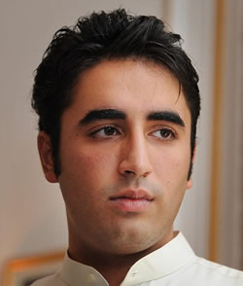Bilawal Bhutto Zardari

**Vice Chairman**

Amin Fahim

**Secretary-General**

Jahangir Badar

**Education Manifesto**

**Access to universal and quality education**

* Education for all to eliminate class divides, gender disparities, poverty and unemployment.
* Every citizen should be able to realize their full potential in society through appropriate educational and vocational skills.
* Combat obscurantism and promote a forward-looking national outlook based on our progressive indigenous traditions and a positive engagement with science, development and universal values.

For implementation, PPP is going:

* Commit 4.5 per cent of GDP to education by the end of our next term.
* Ensure education is treated as a national emergency. This requires effective planning and budgeting as well as a holistic approach to bring about a change in the entire system of education. It requires the development of mechanisms for the exchange of information between different levels of education, and measures to ensure access to schooling for all children.
* Put an end to the abuse of the educational curriculum by removing hate, violence and references to militancy. A comprehensive review of the curriculum will be conducted with the addition of subjects like human rights, ethics, religious tolerance, and community work as well as instruction in hygiene, nutrition, reproductive health, environmental protection and sustainability.
* Carry out comprehensive curriculum and academic reform and, for the first time, review and reform language policy with stress on both mother tongue instruction as well as the appropriate introduction of national and international languages.
* Initiate madrassa reforms with the help of madrassa councils to modernize their education systems. No militias will be allowed to seek refuge under the aegis of a maddrassa to carry out militant activities.
* Back up the constitutional mandates with fiscal allocations that prioritize universal basic education.
* Create a cell within provincial education departments to monitor, coordinate and overview district-wise utilization of the education budget.



