MUTTAHIDA QUAMI MOVEMENT (MQM)
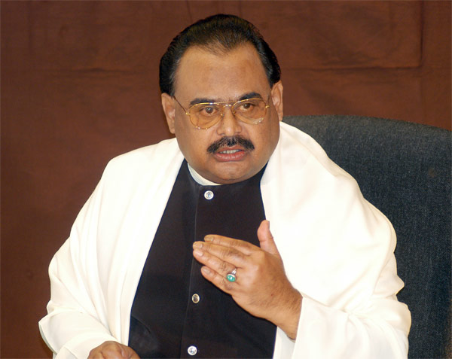
Chairman and Founder
Altaf Hussain
Spokesperson
Haider Abbas Rizvi
Deputy Convener
Anees Qaim Khani

EDUCATION MANIFESTO
Education is the fountainhead of all technological progress and social development, and technology is the key to economic growth. It combats, unemployment, provides social equality, awareness, tolerance, self esteem and especially counters the spread of cultural and plural diversity. Like other social sectors, Education too is riddled with manifold problems.
MQM thus proposes to:
- Gradually increase education expenditure from 2.2% to 5% of the GDP, whereas Provinces need to allocate 20% of their revenue budget to education sector.
- Present dual system of education be abolished, not to degrade the privately managed institutions, but to upgrade the Urdu medium public sector educational institutions at par with the Grammar and English medium institutions.
- Measures be taken to drastically revise the syllabi of the public sector and Urdu medium schools for a uniform syllabi in all the educational institutions.
- Madaris (religious seminaries) be provided incentives to bring such institutions at par with the main stream of education at national level.
- Enrolment of children between the age 5 to 16 years be launched at massive scale both by the government, the civil society and especially NGOs. Since Sindh Assembly on the initiative of MQM has already enacted a Bill in conformity with the provisions of Article 25-A of the Constitution, it is high time that all the provinces follow suit and take measures on war-footing to make education compulsory and free for the children of this age.
- Provinces shall supply free books, uniforms and transport facilities to school going children.
- Introduce an evaluation system through Key Performance Indicators (KPI) which need to be monitored by the Community Management Boards at taluka/tehsil and district level to sustain the growth of literacy and standard of education and to ensure minimal dropout rate and no corporal punishment to the students.
- Every Province need to draw plans for the refurbishing of school buildings, provision of drinking water, washrooms, boundary walls and security arrangements.
- Actively encourage ‘adopt-a-school’ policy to ensure that philanthropists play an active role in promoting free education
- Put on fast track the moto, ‘enter to learn’; and ‘go to earn’ especially in vocational schools
- Launch extensive training and refresher courses for primary and secondary school teachers
- The examination system will be made more transparent and rigorous.
- Grants and scholarship will be provided to such brilliant students who show best results and seek higher education both at home and abroad, especially for students who come from financially disadvantaged background.
- Official grants for professional colleges, like medical and engineering- so as to lessen the fee-burden for those poor students who cannot afford to bear the burden of high-fees.
- Reintroduce/ strengthen the role of elected students unions.
- Establish a network of public libraries, including digital libraries
MQM is determined to undertake all above measures to meet the challenge of education emergency. By developing across the board consensus, MQM will work on legislation, provision of additional financial resources, enrolment drives, reforms in syllabus and curriculum and most importantly the national and international organizations and foreign expertise to formulate, implement and ensure optimal utilization of funds for the growth of our Nation through a world class education system.

